Reprinted from Crop Science Vol. 20, March-April 1980, p. 239-244
Root Growth and Dry Matter Distribution of Soybean as Affected by Phosphorus Stress, Nodulation, and Nitrogen Source¹
K. G. Cassman, A. S. Whitney, and K. R. Stockinger²
gy reducing nitrate when NO₃-N is the source of available N. Thus, for legumes able to form symbiotic associations with
Rh izobium, the pattern of dry matter distribution (DMD) within the plant will differ depending upon its mode of N nutrition.
The partitioning of dry matter between root and shoot is a heritable characteristic determined by the genotype of the plant (Andrews, 1939; Shank, 1943). Root morphology likewise is considered to be genetically determined (Smith, 1934; Zobel, 1975; Street, 1969). The expression of these characteristics can be altered by environmental conditions. Deficiencies of essential mineral nutrients have been shown to affect both the DMD within the plant and lateral root development. Plants deficient in N or P tend to accumulate relatively more dry matter in their roots than do plants which are adequately supplied (Turner, 1922; Brouwer, 1962). Weisum (1958) demonstrated that root branching in pea (Ptsum sattvum L.) was stimulated by nutrients as follows: NO₃-N>P>K> Mg>Ca. Nitrate applied to a discrete root segment increased both the rate of lateral root extension and number of lateral roots per unit length of root (Hackett, 1972; Mdntyre and Raju, 1967; Drew, 1975).
The establishment of an active N-fixing nodule system on the roots of a legume complicates these relationships. During the vegetative stage of growth, active root nodules utilize significant quantities of photosynthate for nodule growth and for N fixation (Minchin and Pate, 1972; Herridge and Pate, 1977). Summerfield et al. (1977) found that the root:shoot dry weight ratio in cowpea (Yigna unguiculata L. Walp.) was larger in nonnodulated plants than in nodulated plants grown at equivalent levels of applied N. Experiments with red clover (Trifolium pratense L.) and barrel medic (Medicago tribuloides Desr.) indicate that there is an inverse relationship between nodule number and lateral root formation (Nutman, 1948; Dart and Pate, 1959). Also, there are qualitative observations concerning differences between the root morphology of grain legumes provided combined N and those which are effectively nodulated (Weber, 1966; Wych and Rains, 1978).
The purpose of this study was to define the changes in DMD and root development in the soybean plant as influenced by the mode of N nutrition, the magnitude of root nodulation, and P deficiency.
ABSTRACT
In the field, plant root development is of primary importance under P deficient conditions. Two sand culture experiments were conducted to examine the effects of P stress, nodulation, and N source on the growth, dry matter distribution, and root development of “Clark 63” soybean (Glycine max L. Merr.). In both experiments two levels of N (0 and 5.0 mM N) were employed: plants were either solely dependent upon symbiotic N fixation (N-fixing), or primarily dependent upon uptake of combined N from the nutrient solution (N supplied). Nodule dry weight of N-fixing plants grown at the highest P level (2.0 µ/ml) comprised 9%, of total plant dry weight and 61% of root dry weight of 35-day-old soybeans. A decrease in the P supply inhibited nodule growth relatively more than either root or shoot growth. For Neupplied soybean, a decrease in the P supply affected shoot growth relatively more than either nodule or root growth. When grown at intermediate P levels (0.02 to 0.5 µ/ml), the root + nodule:total plant dry weight ratio was similar in both N-fixing and N~applied plants. However, the root:total plant dry weight ratio of N-fxing plants was was less an that of N-supplied plants at aft P levels. There was an inverse relationship between nodule mass and total root length although the number of first-order lateral roots on nodulated and nonnodulated plants was the same.
The data suggest that two functional equilibria operate in the N-fixing plant, namely, the partitioning of dry matter between (9 the underground portion of the plant and the shoot and (ii) the root and nodules. Phosphorus stress affected the root-nodule equilibrium relatively more than the partitioning of dry matter between below ground and above-ground parts the plant.
Additional index words N fixation P deficien , Acetylene reduction, Root:shoot ratio, Glycine max Merr
_____________________
SYMBIOTIC N fixation by legumes requires substantial changes in root morphology and physiology. The root nodules represent an added sink for photosynthate and mineral nutrients and compete with other plant organs for the assimilates they require. A nonnodulated legume does not have this additional assimilate sink although it does expend ener-
__________
¹ Journal series No. 2388 of the Hawaii Agric. Exp. Stn. Based in part on the dissertation submitted by the senior author in partial fulfillment of the Ph.D. Degree, Univ. of Hawaii. This research was supported under UH/USAID Contract ta-C-1207 (NifrAL Project, P.O. Box O, Paia, Maui, HI 96779). Received 4 Sept. 1979.
²Research assistant, professor- of agronomy, and senior agronomist, respectively NifTAL Pro]ject, Dep. of Agronomy and Soil Science, Univ. of Hawaii, Honolulu, HI 96822.
2
CROP SCIENCE, VOL. 20, MARCH-APRIL 1980
MATERIALS AND METHODS
Plant Culture Technique

Two pot experiments were conducted during June and July, 1977, at the NifTAL Project greenhouse, island of Maui, Hawaii. Average maximum and minimum greenhouse air temperatures were 31 and 23 C, respectively. In both experiments 3.8-liter pots were filled with 4 kg of silica sand which had been thoroughly rinsed with tap water to remove fine particles and then leached with two pot volumes of demineralized water. Nutrient solutions were prepared with demineralized water. A basal nutrient solution was used containing 1.5 mM CaCl₂, 0.75 mM MgSO₄ 0.5 mM K₂SO₄ 10 µM H₃BO₃, 4 µM FeSO₄, 2 µM MnSO₄, 1 µM KI, 1 µM ZnSO₄, 0.5 µM CuSO₄, 0.1 µM NaMoO₄, and 0.2 µM CoC1₂. In Experiment 1 the nutrient solution contained 15.5 µg P/ml as KH₂PO₄. In Experiment 2 the P levels varied as will be described later. In both experiments the N concentration in the +N nutrient solutions was 5.0 MM supplied as 1.5 mM Ca(NO₃)₂ and 1.0 mM NH₄NO₃. The varying anion was Cl⁻ and the +N and -N nutrient solutions were the same with respect to all other ions. The pH was initially adjusted to 6.8 with 0.1 N NaOH.
Seeds of 'Clark 63' soybean were surface sterilized, regerminated, and four seedlings planted in each pot. At planting each seedling was inoculated with 2 ml of a broth inoculum containing Rhizobium strain TAL 379 (=USDA 136 b = CB1809). Viable plate counts indicated that each seedling received 4 X 10⁷ viable rhizobia. One week after planting pots were thinned to the two most vigorous plants.
Experiment I employed two levels of N (0 and 5.0 mM N, hereafter designated -N and +N) and two inoculation treatments (no inoculum and inoculated, hereafter designated -I and +I) in a factorial design with three replications. Beginning 3 days after planting and continuing until the end of the experiment, pots were watered daily with 800 ml of the appropriate nutrient solutions. This was equivalent to the maximum water holding capacity of the 4 kg of silica sand in each pot. Excess nutrient solution was discarded in the drainage.
In Experiment 2 there were six P treatment levels (0.005, 0.02, 0.05, 0.20, 0.50, and 2.0 µg P/ml, hereafter designated P, through P,) which were combined factorially with two N treatment levels (0 and 5.0 mM N, hereafter designated -N and +N). Each treatment was replicated three times. At planting, all pregerminated seeds were inoculated as previously described. Starting 3 days after planting. pots were watered daily with 800 ml of nutrient solution containing the appropriate P concentration. The N regimes for all +N treatments were initiated 16 days after planting at which time all pots were fitted with a 5-liter nutrient solution reservoir. An aquarium pump was used to recycle the nutrient solution through each pot at a rate of 12 ml/min, sufficient to cycle the entire nutrient solution through each pot thrice daily. The P concentration in the nutrient solution in each treatment was monitored and replenished on a daily basis: 20-ml aliquots were collected from each pot and replicate samples pooled; P concentration was measured using the method of Watanabe and Olsen (1965); P levels were then restored to the original treatment levels. The pH, of the nutrient solution was also monitored and adjusted on a daily basis using 0.2 N KOH. Transpirational water loss was replenished with demineralized water. The entire nutrient solution in each pot unit was replaced with fresh solutions 23, 29, and 34 days after planting. The depletion of NO₃-N from the +N treatments was determined for the 24-hour period following the final nutrient solution change (day 34) using the cadmium reduction method (APHA, 1975).
Growth Analysis and Acetylene Reduction Measurement
In Experiment 1 plants were harvested 21 days after planting. Stems were cut at the sand surface, roots carefully washed free of sand, and nodules picked from the fresh root samples and counted. The number of all first-order lateral roots on the
- tap root were counted. Lateral roots were then cut from the tap root and the total length of first- and second-order lateral roots was measured directly. Roots, nodules, and shoots were dried at 55 C and weighed.
In experiment 2 the treatments were harvested between 1200 and 1400 hours 35 days after planting. Stems were cut at the
sand surface and roots gently removed from the sand. Root systems from each pot were immediately placed in 2-liter bottles, injected with 100 ml acetylene (0.05 atmosphere C₂H₂, and incubated .for 1.5 hours. Ethylene was determined by gas chromatography. Nodules were picked from the root systems. Roots. shoots, and nodules were dried at 55 C and weighed.

RESULTS
Experiment I

Pregerminated seedlings emerged from the sand 1 to 2 days after planting. When pots were thinned, 7 days after emergence, small nodules were visible on the roots of plants in the -N+I treatments. No nodules were apparent on the roots of plants from -I or +N treatments. By Day 14, during expansion of the first trifoliolate leaf, the leaves on -N plants had become chlorotic. In the -N-I treatment, the plants became increasingly chlorotic until harvest. At Day 16 the leaf veins on plants in the -N+I treatment began to turn green and by harvest these plants were a normal color. At harvest +N plants were markedly larger and had a darker green leaf color than did -N+I plants.
The data from Experiment 1 are presented in Table 1. A few small nodules were found on the roots of some uninoculated plants. These nodules were immature and -contained no visible leghaemoglobin which indicated that contamination occurred late in the experiment. Roots from the -N+I treatment were well nodulated; the largest nodules were observed on the upper portion of the tap root. The roots of plants from the +N+1 treatment had numerous small nodules dispersed throughout the root system, most of which were too small to remove from the root for dry weight determination. Plants from +N+I treatments had more nodules but less total nodule dry weight than their -N+I counterparts.
Total dry matter yield of soybean plants from +N treatments was nearly double that of -N plants (Table 1). Inoculated plants had less extensive root systems than uninoculated plants grown under the same
N regime as shown by total root length. There was . an inverse relationship between nodule dry weight and total length of first- and second-order lateral roots. However, there was no significant difference in the total number of first-order lateral roots among treatments. Total root length was significantly correlated with root dry weight (r = 0.94).
Experiment 2
,
The N regimes for +N plants were initiated 16 days after planting. Day 16 was chosen because it coincided with the appearance of green leaf veins in the first trifoliolate leaf indicating that effective transport of symbiotically fixed N to the shoot had begun. Plants grown in the P₅+N and P₆+N nutrient solutions developed flushing branches from the axils of cotyledon, primary and subsequent trifoliolate leaves. The -N plants grown at the same P levels developed few axillary branches.
Brown necrotic spots began to appear on the expanding second trifoliolate leaf (Day 19) of plants grown in the P₁, P₂, and P₃ nutrient solutions with and without N. This necrotic spotting was most severe on the youngest leaves. However, these deficiency symp-
toms did not appear on the third trifoliolate leaf and thereafter the expression of P deficiency symptoms occurred only on older leaves as marginal and interveinal chlorosis which had developed into marginal browning at harvest. Growth of plants at the three lowest P levels was severely stunted regardless of the N source. Phosphorus deficiency symptoms were only slightly apparent at harvest on some plants in the P₄ treatments. First flowering occurred 26 days after planting and there was no effect of P or N on the time of flowering. Small pods were present on all plants at harvest.
The dry matter yield was significantly affected by both P supply and N source (Fig. 1). The highest dry matter yield was produced by plants grown with 2.0 μg P/min the nutrient solution in both the +N and -N regimes. The NxP interaction was highly significant. The presence or absence of N in the nutrient solution did not significantly affect the dry matter yield at the four lowest P levels; however, the dry matter yield of plants in the P₅-N and P₆-N treatments was only 68 and 57%, respectively, of the comparable +N P treatments. The presence of 5.0 mM N in the nutrient solution was sufficient to inhibit nitrogenase activity, as measured by acetylene reduction, at all but the highest P level (Fig. 2). Measurement of the N0₃-N depletion from the nutrient solution during the 24-hour period following the final nutrient solution change showed that the NO₃-N concentration in nutrient solutions of plants growing at the five lowest P levels remained constant while plants in the
rhizobia in the nodules and assimilated by the plant. In both experiments, two N treatments were employed to establish these two distinct modes of N nutrition. In Experiment 1, the +N nutrient solution did not inhibit nodulation in +I treatments although nodules were extremely small and had no visible leghaemoglobin. In Experiment 2, both -N and +N plants were inoculated at planting and the +N regime was not initiated until 16 days after planting. The +N plants were inoculated to provide an internal control since it can be assumed that if nodule mass and nitrogenase activity are severely inhibited, the N supplied in the nutrient solution was sufficient to meet the N requirement of the soybean plant during growth (Allos and Bartholomew, 1959). The data presented in Table 2 and Fig. 2 show that there was little nodule mass and nitrogenase activity in the +N plants at all but the highest P level. It is concluded that the +N and -N treatments in both experiments provided suitable growth conditions to assess the effect of these two modes of N nutrition upon growth, DMD,. and root
P6 + N treatment were active in the uptake of NO₃-N. This indicated that the N supply in the pot system was not sufficient to completely inhibit nitrogenase activity in 5-week-old plants grown at the highest P treatment. Nitrogenase activity in the -N P treatments was significantly correlated with total dry matter yield (r = 0.97) and reached a maximum rate of 87 µmoles C₂H₂ reduced/plant-hour for plants grown at the P₆ level.
The P supply and the mode of N nutrition affected the DMD within the soybean plant. The data presented in Table 2 indicates three trends. First, the top:total plant dry weight ratio increased as the P supply increased.. The mode of N nutrition did not significantly affect this ratio. Second the root:total plant dry weight ratio in both the -N and +N treatments decreased as the P supply increased although at any given P level there was a larger root:total plant dry weight ratio in plants from the +N treatments. Third, in the -N treatments there was a 12-fold increase in nodule dry weight across P treatments compared with a two- and six-fold increase for root and shoot dry weight, respectively. In the +N treatments the top dry weight showed the greatest response as the P supply increased.
The mode of N nutrition did not significantly affect the relative. distribution of dry matter between the shootand the underground portion of the plant in the intermediate P treatments (P₂, P₃, P₄, and P_{s}). There was no difference in the root + nodule:shoot dry weight ratio between -N and +N treatments at each of these P levels and this was true regardless of total plant weight (Fig. 3a). However, at any given P level the mode of N nutrition did affect the root:total plant dry weight ratio (Fig. 3b). Effective nodulation of soybean plant roots significantly decreased the root: total plant dry weight ratio of -N plants relative to those in the +N treatments at equivalent P levels.

DISCUSSION

The soybean plant can meet its N requirement for growth in two ways: (i) it may absorb N that is available in soil; (ii) atmospheric N₂ may be reduced by
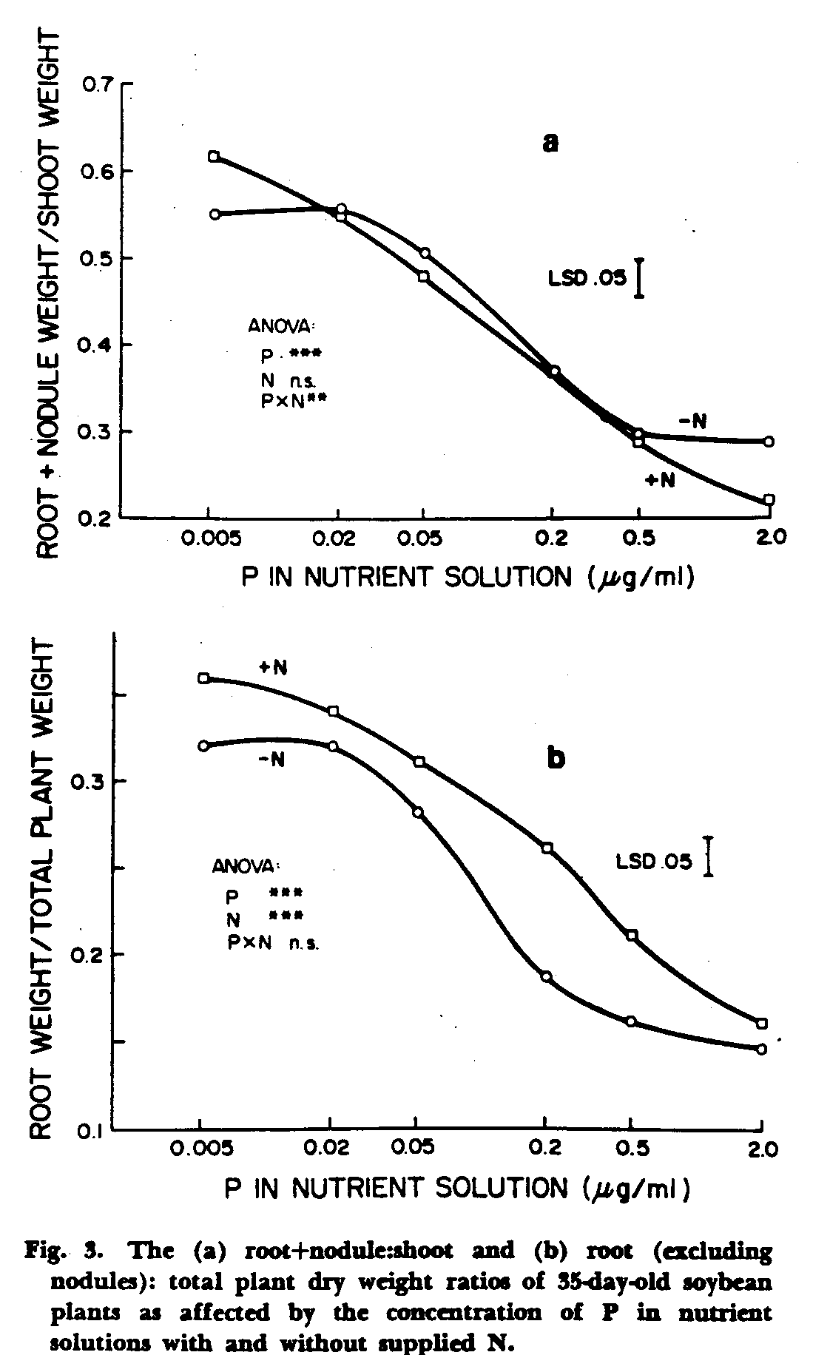
CROP SCIENCE, VOL. 20, MARCH-APRIL 1980
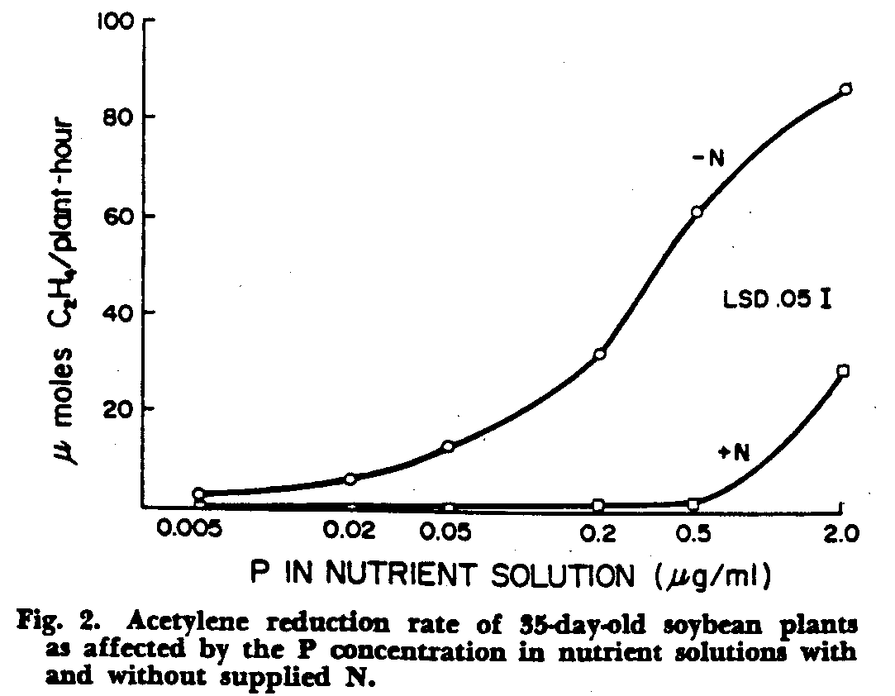
4
CASSMAN ET AL.: ROOT GROWTH OF SOYBEAN
243
development in the soybean plant with the exception of the P₆+N treatment in Experiment 2.
Experiment 1 suggests that there is an inverse relationship between nodule mass and total root length. This could not be attributed to a reduction in the number of first-order lateral roots. Rather, the observed decrease in total root length was caused by a reduction in lateral root extension. These findings contradict the hypothesis that nodules are formed at lateral root initiation sites, as proposed by Nutman (1948) for red clover.
The data from Experiment 2 show that for soybean plants dependent upon symbiotically fixed N, the P supply affected nodule growth relatively more than the growth of shoot or roots (Table 2). In the lowest P treatment (P₁-N), nodule dry weight was 4% of total plant dry weight and 12% of root dry weight. In the hi ghest P treatment (P₆-N), nodule dry weight comprised 9 and 61% of total plant and root dry weight, respectively. For N-supplied plants, nodule dry weight represented a much smaller proportion of both total plant and root dry weight at all levels.
Brouwer (1962) hypothesized that if there is a suboptimal nutrient supply, the growth of shoots will be checked sooner that than of roots because the latter are closer to the source of the deficient nutrient. For soybean, P stress does increase the root:total plant dry weight ratio in the -N and +N treatments (Fig. 3b) as predicted by this hypothesis. Brouwer (1962) also suggested that there is a "functional equilibrium" in the partitioning of dry matter between the shoot and root and that this equilibrium is altered by a suboptimal nutrient supply. At each of the intermediate P levels the relative distribution of dry matter between the underground and aboveground portions of the plant were similar for both N-fixing and N-supplied plants (Fig. 3a). At the lowest and highest P levels, the relative distribution of dry matter between the shoot and the underground portion of the plants differed depending upon the mode of N nutrition. For soybean plants dependent upon symbiotically fixed N, photosynthate translocated to the below-ground portion of the plant was utilized for both the growth and function of roots and the growth and function of nodules. Consequently, the root: total plant dry weight ratio of plants from -N treatments was always less than that of plants from +N treatments at equivalent P levels (Fig. 3b). This indicates that nodules and roots were competitive sinks for photosynthate translocated from the shoot to the underground portion of the plant during the establishment and vegetative stages of growth. Thus, for the N-fixing soybean plant, we conclude that a second functional equilibrium was operative, namely, the partitioning of dry matter between the root and nodule and this equilibrium is more sensitive to P stress than the partitioning of dry matter between the shoot and the underground portion of the soybean plant (Table 2). Lawn and Brun (1974) demonstrated a similar competitive sink relationship between the nodules and developing pods during pod-fill in soybeans.
An inverse relationship between soybean root development and nodule mass should have important agronomic implications. Other growth characteristics being equal, an extensive root system enables the plant
to exploit soil reserves of moisture and nutrients efficiently. The difference in the root:total plant dry weight ratio between N-supplied and N-fixing soybean plants was greatest when the P supply was suboptimal. Therefore,, it is possible that effectively nodulated soybeans grown on N-deficient soil would be more susceptible to growth limitations caused by deficiencies of essential mineral nutrients or drought compared with their N-fertilized counterpart, especially during early growth. Fertilizer use efficiency for macronutnents other than N might also be affected by the mode of N nutrition. In a field experiment, Ham and Caldwell (1978) reported that nonnodulating soybeans fertilized with 100 kg N/ha and 35 kg P/ha had nearly double the P fertilizer use efficiency of nodulated soybeans fertilized at the same P rate but with no fertilizer applied. It is possible that the more efficient utilization of P fertilizer by the nonnodulated soybean fertilized with N was caused by the development of a more extensive root system during early crop growth, before the applied P fertilizer had completely reacted with the soil. The data from Experiment 1 in this study showed that there was indeed a significant early growth response to supplied N in root dry weight, total root length, and top dry weight of 21-day-old soybean (Table 1).
In experiments discussed in this paper we have shown that nodulation, P stress, and mode of N nutrition affects soybean root development and dry matter distribution. However, we have compared these relationships at two extreme modes of N nutrition only. Most field-grown soybeans derive N both from soil and from symbiotic N fixation. It should be. worthwhile to study these relationships at intermediate levels of N supply which more closely approximate N availability in soil. A better understanding of the effects of nodulation, nutrient stress and N availability on soybean ontogeny could lead to improved husbandry practices in the field.

REFERENCES

1. Allos, H. F., and W. V. Bartholomew. 1959. Replacement of symbiotic fixation by available nitrogen. Soil Sci. 87:61-66.
2. Andrews. F. S. 1939. Root-top ratio of bush lima bean as an index of adaptability to ecological conditions. Am. Soc. Hort. Sci. Proc. 37:752-758.
3. APHA. 1975. Standard methods for the analysis of water and waste water. 14th Ed. p. 423-427.
4. Brouwer, R. 1962. Nutritive influences on the distribution of dry matter in the plant. Neth. J. Agric. Sci. 10:399-408.
5. Dart, P. ., and J. S. Pate. 1959. Nodulation studies in legtimes. II . The effects of delaying inoculation on the seedling symbiosis of barrel medic. J. Aust. Biol. Sci. 12:427-456.
6. Drew, M. D. 1975. Comparison of the effects of a localized supply of phosphate, nitrate, ammonium, and potassium on the growth of the seminal root system and shoot in barley. New Phytol. 75:475-490.
7. Hackett, C. 1972. A method of applying nutrients locally to roots under controlled conditions and some morphologtcal effects of locally applied nitrate on the branching of wheat . roots. Aust. J. Biol. Sci. 25:1169-1180.
8. Ham, G. E., and A. C. Caldwell. 1978. Fertilizer placement effects on soybean yield, nitrogen fixation, and OP uptake. Agron. J. 70:779-784.
9. Herridge, D. F.. and J. S. Pate. 1977. Utilization of net photosynthate for nitrogen fixation and protein production in an annual legume. Plant Physiol. 60:759-764.
6 CROP SCIENCE, VOL. 20, MARCH-APRIL 1980

10. Lawn, R. J. and W. A. Brun. 1974. Symbiotic nitrogen fixa- tion of cowpea. I. Effects of applied nitrogen and symbiotic
tion in soybeans. I: The effect of photosynthetic source-sink nitrogen fixation on growth and seed yield. Exp. Agnc. 13:
manipulations. Crop Sci. 14:11-16. 129-142.
11. McIntyre, G. I., and M. U. S. Raju. 1967. Developmental 18. Turner, T. W. 1922. Studies of the mechanism of the phy
studies on Euphorbia escula L. Some effects of nitrogen siological effect of certain mineral salts in altering the ratio
supply on growth and development of the seedling. Can. of top growth to root growth in seed plants. Am. J. Bot.
J. Bot. 45:975-984. 9:415-431.
12. Minchin, F. R„ and J. S. Pate. 1973. The carbon of a leg- 19. Watanabe. F_ S., and S. R. Olsen. 1965. Test of an ascorbic
ume and the functional balance of its root nodules. J. Exp. acid method for determining phosphorus in . water and
Bot. 24:259-271. NaHCO, extracts from soil. Soil Sci. Soc. Am. Proc. 29:677
13. Nutman, P. S. 1948. Physiological studies on nodule forma- 678.
tion. 1. The relation between nodulation and lateral root 20. Weber, C. R. 1966. Nodulating and nonnodulating soybean
formation in red clover. Ann. Bot. N. S. 12:81-96. isolines: II. Response to applied nitrogen and modified soil
14. Shank. D. B. 1943. Top-root ratios of inbred and hybrid conditions. Agron. J. 58:469.
maize. J. Am. Soc. Agron. 35:976-987. 21. Weisum, L. R. 1958. Density of roots as affected by sub
15. Smith, S. N. 1934. Response of inbred lines and crosses in strate and separate ions. Acta Bot. Neerl. 7:174-190.
maize to variations of nitrogen and phosphorus supplied as 22. Wych, R. D.. and D. W. Rains. 1978. Simultaneous measure
nutrients. J. Am. Soc. Agron. 26:785-804. ments of nitrogen fixation estimated by acetylene reduction
16. Street, H. E. 1969. Factors influencing the activity of meri- and nitrate absorption by soybeans. Plant Physiol. 62:443
stems in roots. p. 20-39. In W. J. Whittington (ed.) Root 448.
growth. Butterworth and Co., Ltd., London, England. 23. Zobel, R. W. 1975. The genetics of root development. p.
17. Summerfield, R. J. P. J. Dart, P. A. Huxely, A. R. J. Eagle- 261-278. In J. G. Torrey and D. T. Clarkson (eds.) The de
sham, F. R. Minchin, and J. M. Day. 1977. Nitrogen nutri- velopment and function of roots. Academic Press, New York.

